***OLED DIGISPEX***

|  |  |
| --- | --- |
| Rutvik Shivalkar Department of Electronics and  Telecommunication  K.C. College of Engineering and Management Studies and Research  Mumbai, [shivalkarrutvik@kccemsr.edu.in](mailto:shivalkarrutvik@kccemsr.edu.in)  Akash Suryavanshi Department of Electronics and  Telecommunication  K.C. College of Engineering and Management Studies and Research  Mumbai,  [Suryavanshiakash@kccemsr.edu.in](mailto:Suryavanshiakash@kccemsr.edu.in) | Vaibhav Shingare Department of Electronics and  Telecommunication  K.C. College of Engineering and Management Studies and Research  Mumbai, [shingarevaibhav@kccemsr.edu.in](mailto:shingarevaibhav@kccemsr.edu.in)  Aniket Shinde Department of Electronics and  Telecommunication  K.C. College of Engineering and Management Studies and Research  Mumbai,  [Shindeaniket@kccemsr.edu.in](mailto:Shindeaniket@kccemsr.edu.in) |

***Abstract***

**The ultimate goal for them to become an augmented reality interface has not yet been attained due to an encumbrance of controls. Augmented reality involves superimposing interactive computer graphics images onto physical objects in the real world. This survey reviews current research issues in the area of human–computer interaction for smart glasses. The survey first studies the smart glasses available in the market and afterwards investigates the interaction methods proposed in the wide body of literature. The interaction methods can be classified into hand-held, touch, and touchless input. This paper mainly focuses on the touch and touchless input. Touch input can be further divided into on-device and on-body, while touchless input can be classified into hands-free and freehand.** **Binded by various sets of protocols many companies do not allow the employees to use mobile phones during the work hours also while one is driving using a phone is a big risk. Yet mobile phones are connecting people in an unimaginable way to the people distant from us and closer to our heart. Due to some workplace rules of not using mobile phones when on work, it may happen that one may miss some urgent call calling out an emergency. So bringing up a solution to this problem, a head mounted . With the advancement in Information and Communication Technology, smart glasses have proven to be one of the modern computing devices that unite humans and machines. The report focuses on how to develop cost effective smart glasses with basic features like date-time, call-notification using arduino board,bluetooth module, OLED panel, Lipo Battery. Smart glasses are used in medical, gaming Applications and the features can contribute to its service in other fields too.**

***Keywords—Arduino Uno Board, Hc-05 Bluetooth, OLED Panel, LiPo Battery,*MAX30100 Pulse Oximeter Heart Rate Sensor**

1. INTRODUCTION

In recent years, smart glasses have been released into the market. Smart glasses are equipped with a see-through optical display, which is positioned in the eye-line of users. The user can view both the real-world environment and the virtual contents shown in the display, which is regarded as the concept of augmented reality.The shift in mobile devices from smartphones to smart glasses will happen over the next decade. It is projected that smart glasses will become the next leading mobile device after the smartphone, according to market research conducted by Digi-capital. Thus, smart glasses have great potential in becoming the major platform for augmented reality. Mobile phones have become the 4th basic necessity for people in the 20th century, but one has to maintain decorum while using a phone at work and are unable to use it sometimes during lectures, meetings or important work and thus one may miss some urgent messages, calls and emails. Smart Augmented glasses would bring a better approach for this problem. One can easily be heedful about the notification alerts, message/call updates. It is basically a hands free approach to streamline notification to users, so that any of the urgent and important notifications does not go off without having users attention. Inspired by Google glass, it is a small approach to connect humans with machines, it is a wearable computing device used as an extension, which can either be attached to the spectacles or sunglasses of the wearer, or can be paired with Smart Phones, via Bluetooth. It’s abilities prove it to be an extraordinarily potent glasses, which accomplishes real-time and enriched interaction between the smart glasses user and the physical world with augmented data.

1. 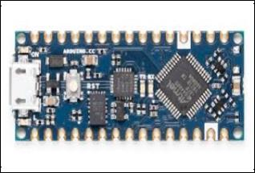*Arduino Nano Board*
2. DESIGN

* 2.4GHz ISM band frequency
* Default baud rate: 9600
* Power supply: 3.6V to 6V DC ● Communication range is less than 20m. ● Transmits files at the speed of2.1 Mb/s.

Fig 1. Diagram of Arduino Nano Board

# Technical Specifications:

* + MicroController - ATmega 332P - 8 bit AVR family microcontroller
  + Operating Voltage -5V
  + Recommended Input Voltage - 7-12 V
  + Analog input pins - 6 (A0 - A5)
  + EEPROM - 1KB
  + Frequency - 16MHz

The Arduino Nano is very much similar to the Arduino UNO. They use the same Processor (Atmega328p) and hence they both can share the same program. One big difference between both is the size UNO is twice as big as Nano and hence occupies more space on your project. Also Nano is breadboard friendly while Uno is not. To program a Uno you need Regular USB cable whereas for Nano you will need a mini USB cable .

1. *HC-05 Bluetooth*

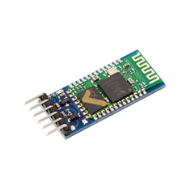

Fig 2. Diagram of HC-06 Bluetooth

# Technical specification :

* + Operating Voltage is 3.3V DC.
  + Bluetooth v2.0+EDR

HC-06 is a Bluetooth module designed for establishing short range wireless data communication between two microcontrollers or systems and it can only act as a slave device. This is the cheapest method for wireless data transmission and more flexible compared to other methods. The module can be interfaced with almost all controllers or processors as it uses UART interface.

When the module receives wireless data, it is sent out through the serial interface exactly as it is received. No user code specific to the Bluetooth module is needed at all in the user microcontroller program (such as Arduino uno and mega).

1. *OLED Display*

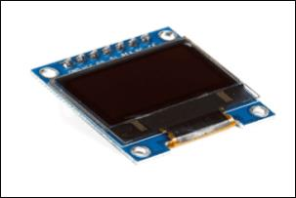

Fig 3. Diagram of OLED Display

# Technical specification :

* + Input Voltage is in range of 6 to 30V DC
  + IP66 rated
  + Power is 1.2W
  + Output capable of supplying 500mA.

Organic Light Emitting Diodes (OLED) is a flat light emitting technology, made by placing a series of organic thin films between two conductors. When electrical current is applied, a bright light is emitted. OLEDs are emissive displays that do not require a backlight and so are thinner and more efficient than LCD displays which do require a white backlight. OLED displays are thin and efficient. They provide the best quality image and they can also be made transparent, flexible, foldable, rollable and stretchable in the future.

# MAX30100 Pulse Oximeter Heart Rate Sensor Module

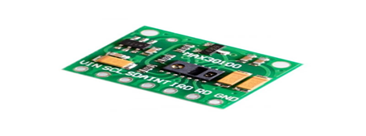

The MAX30100 is an integrated pulse oximetry and heart-rate monitor sensor solution. It combines two LEDs, photodetector, optimized optics, and low-noise analog signal processing to detect pulse oximetry and heart-rate signals.  
The MAX30100 operates from 1.8V and 3.3V power supplies and can be powered down through software with negligible standby current, permitting the power supply to remain connected at all times.

*LiPo Battery*

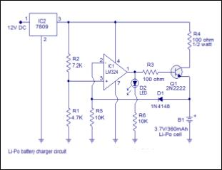

Fig 4. Diagram of LiPo Battery

**Technical Specification:**

* + Nominal Capacity ranges from 332 to 350 mAh
  + Maximum Constant charging current is 350mA ●

Maximum Continuous discharging current is 525mA

* + - Storage Voltage ranges from 3.7 to 3.85 V.

A lithium polymer battery , or more correctly lithium-ion polymer battery , is a rechargeable battery of lithium-ion technology using a polymer electrolyte instead of a liquid electrolyte . High conductivity semi solid polymers form this electrolyte . These batteries provide higher specific energy than other lithium battery types and are used in applications where weight is a critical feature , such as mobile devices and radio- controlled aircraft .

1. METHODOLOGY

Smart glasses are mostly used for handling the tasks related to human to machine interactions. Insight into designing part of smart glasses :

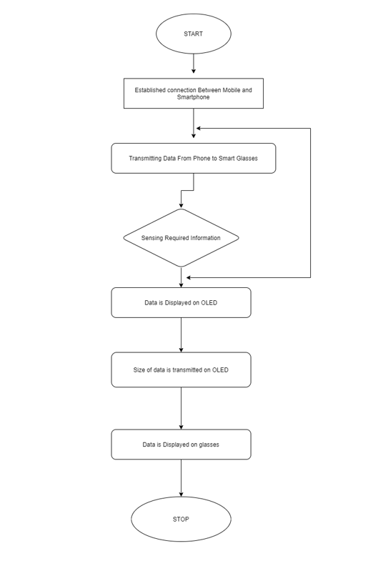

Fig 5. Flowchart of working

* An application connecting the main wearable device and mobile phone. This application should be installed in mobile phones
* The connection will be established through the Bluetooth module and will be active only if the bluetooth of users mobile is turned ON .
* HC-06 Bluetooth model is used on the device side.
* All the wiring and connection cables are perfectly synchronized and connected with the Arduino board.
* Converging property of magnifying glass is combinedly used in this technology.
* After turning the bluetooth on from both the side and setting up connecting cables and Arduino board, connection gets quickly paired up and connected.
* Now, the notifications display on screen even though the user uses the phone.
* When the notification pops on mobile, bluetooth receives the same notifications and sends that notification to the arduino uno.
* The Arduino board then displays the same notified message on the OLED panel display panel which reflects on the mirror i.e placed at 45° angle to the OLED panel.
* The reflected image passes through the magnifying glass and gets converged. The converged image collapsed on the glass screen.
* Finally, here the user acquires the Mobile’s notification.

1. APPLICATIONS

One of the growing trends of wearable computing is Head Mounted Displays (HMD), as the head is a great gateway to receive audio, visual information. To make worth out of technology trends and to make life more easier by wearable computing devices. The aim is to assist people to use augmenting real life with extra information constantly and ubiquitously.

The purpose of the project is to minimize the use of mobile phones while working. The Smart specs help to avoid spams messages and calls received on the phone. Thus, it gives choices to use the phone urgently or not. One can use it at the places where mobile has to be kept at silent mode for eg. Workplace, Library, Hospitals,etc. It can be useful for handicapped or disabled people.

Augmented glasses are innovative, fresh, exciting and bring attention to users who perceive it as useful, valuable, helpful and time saving. It is simple to use, control, convenient and user-friendly.

The smart glasses can be implemented in workplaces where using phones during work hours is strictly prohibited. Even the price issue then can be sponsored by the company to its employees. In this way Employees won’t be kept away from any urgent work calls, family emergencies, etc.

View publication stats

1. CONCLUSION

There are lot of interesting applications which can only or a lot easier be implemented with smart glasses than with traditional computing devices. It is probable that there will be large investments into research and development of smart glasses because the entertainment industry, military and business can benefit from smart glasses and there might be a high consumer demand for them soon. The hardware that will be available in the near future still has its pitfalls and will probably need a few years and iterations to be fixed. Nevertheless, the prototypes available today are very promising and it might happen that smart glasses will be a part of our future everyday life. Be it in cinemas at the workplace, in our entertainment systems or as always connected companion device.

glasses have vast scope in Augmented Reality. As technology advances navigation options along with audio options can be added.

ACKNOWLEDGEMENT

We would like to express our sincere thanks and deep sense of gratitude to K. C. College of Engineering & Technology and Management Studies & Research for giving us an opportunity to integrate the learning from this graduate course.

We take this opportunity to express our profound gratitude and deep regards to our guide, Head of the Electronics and Telecommunication Department, Rajiv Iyer and Guide - Dr AVISHEK RAY for his exemplary guidance, monitoring and constant encouragement throughout our project work titled “ OLED DIGISPECX” and also thanks to Department Faculty & Technical staff members for their time to time help for our project work.

.

I convey my gratitude to my family whose support and blessings were the backbone in making the project come true All the thanks and my gratitude towards my teacher, family, friends, the efforts, the blessings and the guidance which had made it possible to achieve the fulfillment of the assignment.

REFERENCES

1. https://en.wikipedia.org/wiki/Smartglasses
2. https://instructables.com/id/DIY-Smart-Augmented-Reality-Glasses-Using-Arduino/
3. https://www.circuito.io/app?components=512.11021
4. https://www.youtube.com/watch?v=pkB|Nahi-X0